Retention Script Information
Allan Hirt
http://www.sqlha.com
Version 1.0 – January 7, 2008
Table of Contents
About the Retention Scripts 1
Running the Scripts 1
Retention Script Descriptions 6
backup_retention_all_files.vbs 6
backup_retention_all_files_date_folder.vbs 7
backup_retention_all_files_date_folder_with_full_policy.vbs 7
backup_retention_all_files_older_folder.vbs 8
backup_retention_all_files_older_folder_with_full_policy.vbs 8

About the Retention Scripts
In this folder, you will find five variations of a retention script that you can use in your environment. Each script is coded with WMI and VBScript.

If they work “as-is”, pick the one that works the way you want it to, configure the parameters, and that should be it. If these do most of what you want, or you need to customize, just modify the scripts.

All these scripts were tested under Windows Server 2003 with Service Pack 1, so they should work on all flavors of Windows Server 2003. I cannot guarantee they will work under Windows 2000 Server, but they most likely will or would need very little tweaking. If these do not work, please contact me via the website and I will investigate and hopefully issue a fix.

NOTE: You should test these scripts thoroughly before implementing in production. You do not want to accidentally delete something you shouldn’t. I am not responsible if you do that accidentally.

Running the Scripts
The scripts can be executed manually, or scheduled using your favorite scheduler in Windows. I do not recommend running these with xp_cmdshell as part of a SQL Server Agent job to minimize security risks. A retention scripts should be run at least once a day, and I would suggest sometime in the wee hours of the morning.

To use these with the scheduler built into Windows, follow these instructions:
- From the Start menu, select Accessories→System Tools→Scheduled Tasks.
- Double click on Add Scheduled Task.
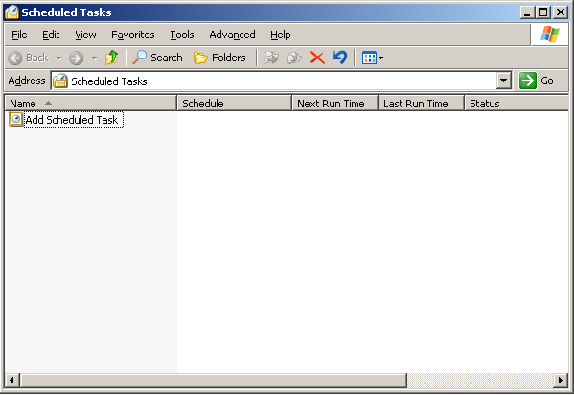

- On the Scheduled Task Wizard dialog, click Next.
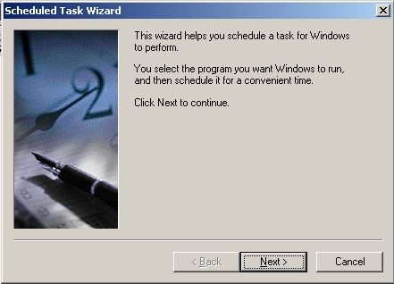

- To select the retention script to schedule, click Browse.
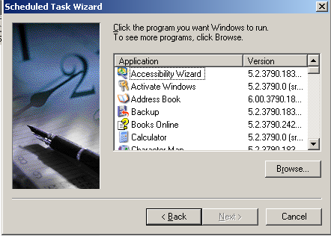

On the Select Program to Schedule dialog, navigate to the folder where the script is located. Select the script, and click Open.
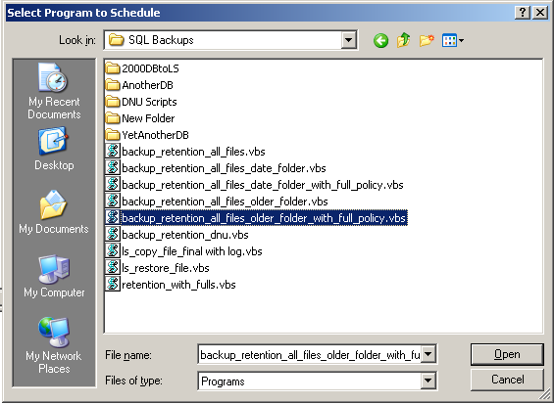

- Enter a name for the scheduled task. By default, it will get the name of the script. Also select how often the script should be run. Click Next to continue.
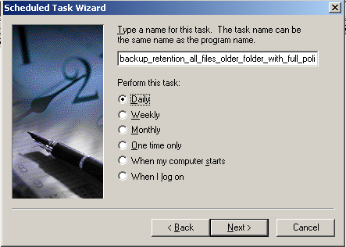

- Enter the time when the task will run. An example is shown below. Click Next.
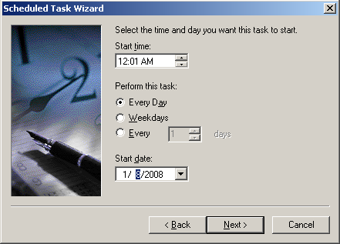

- Enter a valid Windows account that has the proper permissions to execute the script. Click Next.
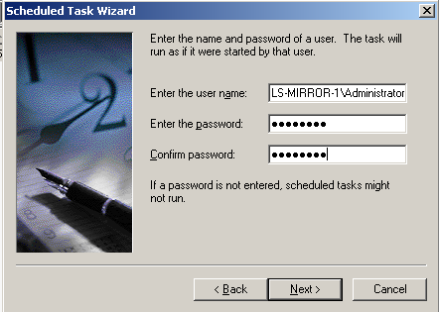

- Click Finish.
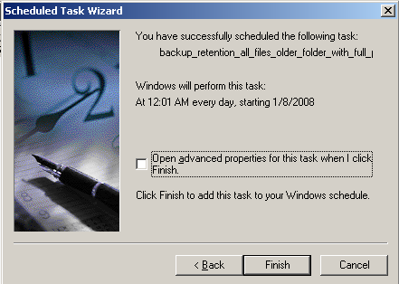

- The new scheduled task will appear in the Scheduled Tasks window.
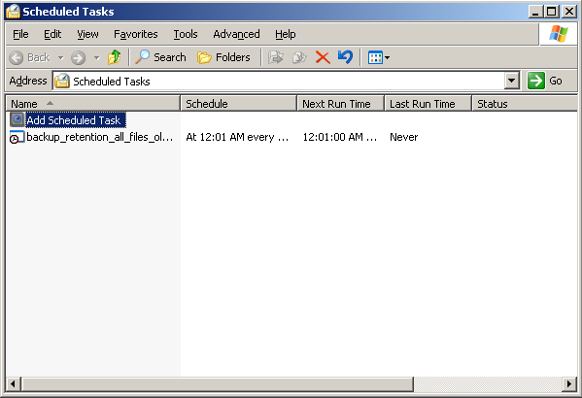

Retention Script Descriptions
This section will describe each of the scripts.

backup_retention_all_files.vbs
This script is as simple as it gets: once you configure the parameters, it will parse all folders and delete all files older than the value specified for RetentionDays.

Parameter | Purpose | Default Value
RetentionDays | 14 | 14
topdir | This is the top-level directory (or only directory) containing the backup files. Do not place a \ after the folder name.
diffext | This is the extension used for differential backup files. | dif
fullext | This is the extension used for differential backup files. | bak
tlogext | This is the extension used for transaction log backup files. | trn

backup_retention_all_files_date_folder.vbs
This script is a bit more complex. Once you configure the parameters, the script will parse all folders and move all backup files that are older than the current date to a dated subfolder that the backup files from that date. The script will also parse the folders and delete all folders that are older than RetentionDays. Once a folder is created, it will be parsed for deletion on the next run of the script.

Warning: Do not place newer files into the dated folders. The script does not check to see if a file in the folder is newer than the date, and would be deleted if the folder is older than RetentionDays.

Here is what the directory structure may look like:
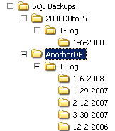

Parameter | Purpose | Default Value
RetentionDays | 14 | 14
topdir | This is the top-level directory (or only directory) containing the backup files. Do not place a \ after the folder name.
diffext | This is the extension used for differential backup files. | Dif
fullext | This is the extension used for differential backup files. | Bak
tlogext | This is the extension used for transaction log backup files. | Trn

backup_retention_all_files_date_folder_with_full_policy.vbs
This script is the same as backup_retention_all_files_date_folder.vbs with one difference: it also enforces a policy for retaining a certain number of full backups as defined by NumFull. The full backups that are kept will be the most recent ones. This script assumes that each database has a subfolder and the backup is in the “root” (i.e. C:\Mainbackupdir\DBDir). If your directory structure is different, the script will need to be modified.

Parameter | Purpose | Default Value
RetentionDays | 14 | 14
topdir | This is the top-level directory (or only directory) containing the backup files. Do not place a \ after the folder name.
diffext | This is the extension used for differential backup files. | Dif
fullext | This is the extension used for differential backup files. | Bak
tlogext | This is the extension used for transaction log backup files. | Trn
NumFull | This is the number of full backups to retain on disk. | 2

backup_retention_all_files_older_folder.vbs
This script is similar to backup_retention_all_files_date_folder.vbs. Once you configure the parameters, the script will parse all folders and move all backup files that are older than the current date to a dated subfolder named Older. Unlike backup_retention_all_files_date_folder.vbs., the files older than RetentionDays will get deleted in the same run as the ones that should b retained are moved to Older.

Here is what the directory structure may look like:
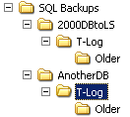

Parameter | Purpose | Default Value
RetentionDays | 14 | 14
topdir | This is the top-level directory (or only directory) containing the backup files. Do not place a \ after the folder name.
diffext | This is the extension used for differential backup files. | Dif
fullext | This is the extension used for differential backup files. | Bak
tlogext | This is the extension used for transaction log backup files. | Trn

backup_retention_all_files_older_folder_with_full_policy.vbs
This script is the same as backup_retention_all_files_older_folder.vbs with one difference: it also enforces a policy for retaining a certain number of full backups as defined by NumFull. The full backups that are kept will be the most recent ones. This script assumes that each database has a subfolder and the backup is in the “root” (i.e. C:\Mainbackupdir\DBDir). If your directory structure is different, the script will need to be modified.

Parameter | Purpose | Default Value
RetentionDays | 14 | 14
topdir | This is the top-level directory (or only directory) containing the backup files. Do not place a \ after the folder name.
diffext | This is the extension used for differential backup files. | Dif
fullext | This is the extension used for differential backup files. | Bak
tlogext | This is the extension used for transaction log backup files. | Trn
NumFull | This is the number of full backups to retain on disk. | 2

